Designing Touch: Touch-Effort for Tactile Input Based on Laban Effort-Shape Analysis

Thecla Schiphorst
Associate Professor
School of Interactive Arts and Technology
2400 Surrey Place,
10153 King George Highway,
Surrey, BC V3T 2W1 Canada
+1 604 586 5279
thecla@sfu.ca
Robb Lovell
School of Interactive Arts and Technology
2400 Surrey Place,
10153 King George Highway,
Surrey, BC V3T 2W1 Canada
+1 604 586 5225
lovell@siliconatelier.com
Norman Jaffe
Aurel Systems Inc.
7197 Ridgeview Drive
Burnaby, BC V5A 4S1 Canada
+1 604 299 7707
turing@shaw.ca

ABSTRACT
In this paper, we describe the development of a parameterized touch-effort recognition system for use with systems that require qualitative information about user’s intentionality within a real-time environment.
The parameterized model provides high-level, qualitative and 'intentional' interpretations for the interface, which is used to derive a set of touch-efforts for the interaction model; the parameters are based on Laban's Effort-Shape Analysis system, which has been used to analyze and describe movement effort qualities in 3D space. Laban’s system is adapted here to describe the qualitative aspects of caress as a function of tactility. A set of fourteen touch-efforts have been modeled and tested based upon a set of extracted tactile parameters.
A touch-sensitive tablet or wearable armband, capable of rapidly detecting multiple simultaneous contacts, is used to provide a source of tactile gestures (such as caressing, pressing, tapping, gliding, slapping, patting). The data from the input device is locally processed and then interpreted by pattern processing algorithms to extract parameters and for the evaluation of the touch-shape.

KEYWORDS
Pen and Tactile Input, Input and Interaction Technologies, Multidisciplinary Design / Interdisciplinary Design, User-Centered Design / Human-Centered Design, User Experience Design / Experience, gestural analysis, tactile input, gesture recognition, gesture toolkit, Laban Effort-Shape analysis, movement analysis, gesture-based interface, whole hand input, Max/MSP, Tactex MTC
Intentionally
blank

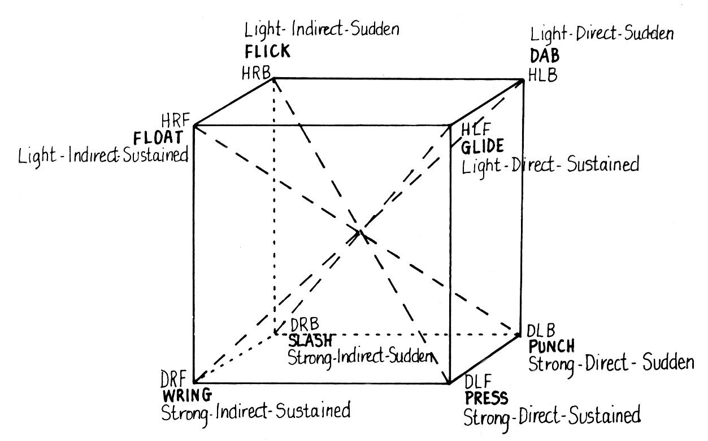
Figure 1.

INTRODUCTION

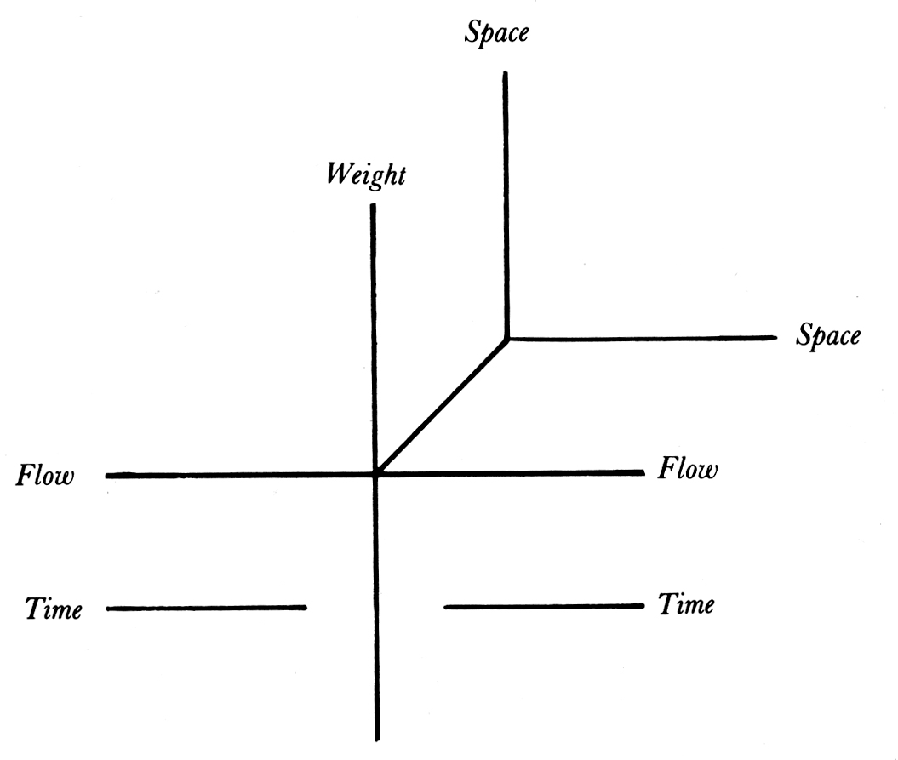
Figure 2.

IMPLEMENTATION
The implementation of our parameterized gestural interface uses a Tactex MTC-Express (Multi-Touch Controller) pad (www.tactex.com) in conjunction with the “eyes” plug-in (www.squishedeyeball.com) for the MAX/MSP graphical environment for music, audio and multimedia (www.cycling74.com).
Data from the MTC pad is input as an 8 bit, 6 by 12 pressure image into the “eyes” environment within MAX/MSP, with some filtering performed using the internal DSP of the MTC. The image is then processed as a visual representation used by the “eyes” software, to extract ten (out of twelve) parameters that we have identified as representing physical values that can be extracted or calculated from the information that the MTC pad provides over time. These parameters are described in Table 1.

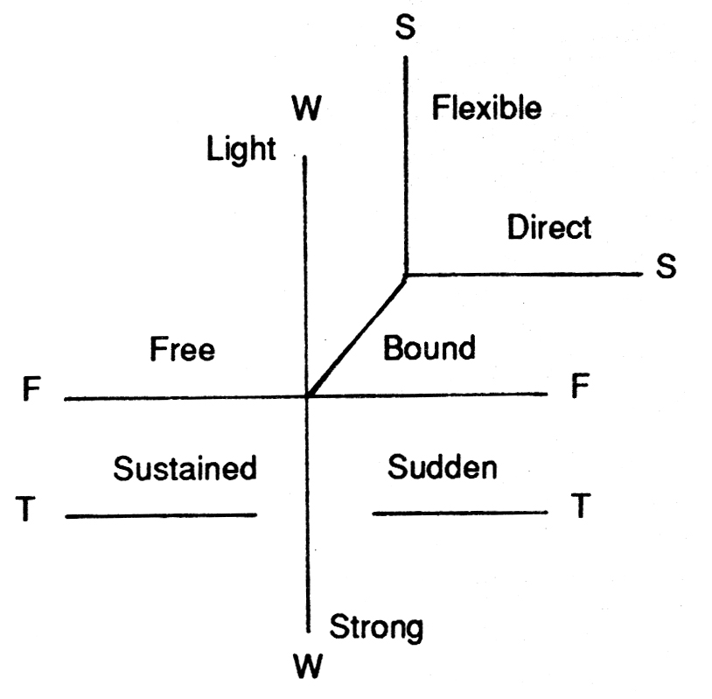
Figure 3.

Parameter: |  | Description
pressure | soft-hard | The intensity of the touch, how hard or soft.
time | short-long | The length of time a gesture takes.
size | small-medium-big | The size of the part of the interaction object that touches the pad.
number | one-many | The distinction between one finger or object and many fingers.
speed | none, slow-fast | The speed of a touch-effort. This is the overall velocity of movement. This parameter is not used directly to distinguish efforts, but is used to determine space.
direction | none, left, right, up, down, and four diagonals | The direction of movement. This parameter is not directly used to distinguish efforts, but is used to determine space and path.
Secondary:
space (speed) | stationary-traveling | A function of speed. If speed is zero, then the gesture is stationary, otherwise it’s traveling.
path (direction) | straight-wandering | If the speed is not zero, and there are no more than one direction registered, the gesture is straight.
disposition (pressure) | constant-varying | If the pressure maintains a single value after an initial acceleration, the gesture is constant, otherwise it’s varying.
disposition (size) | constant-varying | Not used.
disposition (number) | constant-varying | Not used.
pattern (gesture) | continuous-repetitive | If a gesture is unique in relation to the gesture immediately before and after, it is continuous. Any repeated action or gesture is classified as repetitive.
Table 1.

We have identified fourteen touch-efforts, based upon discussions between members of our team. This is an initial pass at a possible set of touch-efforts and further research must be done to determine if they are representative. We recognize that there is a wide degree of subjectivity in the evaluation of touch-effort both within and between cultures and do not present these as a comprehensive or verifiably representative list.
We chose twelve touch-efforts to extract, out of the set that we identified, based upon what we perceive as possible for the computer to distinguish, given the sensor data we have available and the parameters we are extracting. The fourteen efforts that have been identified are listed and described in Table 2.

touch-effort | Description
tap | A soft, short, small, touch, usually rendered with a single finger.
pat | A bigger version of “tap” and a soft version of “slap”. Usually rendered with an open hand or palm.
hold | A lingering, soft, big, touch. A “hold” has an encompassing feel.
touch | “Touch” is a small version of “hold”. It is an indication of comfort and is rendered with the fingers, hand, or palm.
stroke | A traveling touch, soft but directional, rendered with fingers, hand or palm.
glide | A traveling, meandering, touch. Soft and directionless and rendered with the fingers, hand, or palm.
jab | A hard, short, small, touch. A hard poke by a finger or blunted object. Also known as “poke”.
knock | A medium-sized, fist against, rapping hard. In our scheme, it is different than “jab” and “slap” in size only.
slap | An open handed, hard, short, touch. In our scheme, a large version of “jab” and “knock”.
press | This is a long, hard, touch.
rub | This is a moving, hard, touch.
knead | Kneading involves many fingers moving hard and in a slightly wandering fashion.
other touch- | efforts not attempted in this system:
punch | This is like a “knock”, but is different in intensity and slightly different in timing.
flick | This is like a “jab”, but is slightly different in shape over time. A “flick” travels slightly in relation to a “jab”, which is more stationary.
Table 2.

Since the goal is to extract the overall quality of the touch, and the MTC pad is small, it is assumed that all readings from the pad come from one hand (not necessarily true, but useful as a starting point). It is also assumed that, at any given moment, there is only one touch-effort intended by the user. For instance, the person is not tapping with one finger and jabbing with another. With these assumptions, it becomes possible to ignore differences between areas within the pressure image that are distinct and to measure values as a collective between these regions.
To simplify the decision process used to determine what quality of touch is used, we take a fuzzy approach and use some techniques borrowed from Laban. The rationale for this is that parameters generally aren’t represented linguistically by gradations of numbers, but are described in more dualistic terms such as “soft” or “hard”, “fast” or “slow” and “short” or “long”. There are exceptions to this rule, such as the parameter size, where it is useful to think of three or four levels (“small”, “medium”, and “big”) within the context of the MTC pad. Also, time can be divided more finely into “short” and “long” (“long” being not “short”). By categorizing each parameter into two or three qualitative values, the number of possible touch-efforts is reduced to a manageable quantity, more representative of the actual types of touches that we have identified.
After the extraction of a numeric value for each of the parameters below, they are quantized into one of four (or five) states: not active, between one extreme or the other and the two or three quantized values. Quantized values are subject to thresholds that currently must be determined empirically.

Pressure (soft-hard),

Size (small-medium-big),

Speed (fast-slow),

Time (brief-long), and

Direction (eight directions)
These four parameters are the easiest to extract because they can be determined by simple image processing techniques of segmentation and region extraction. Pressure and size are determined after segmentation by averaging or lumping all pixels above a noise threshold into one value.
Speed is a challenge because several blobs may move in a way that doesn’t represent the overall speed at which things are moving. Here we distinguish between direction and speed: direction is signed, and speed is always positive. By adding up the speeds of all regions a usable picture emerges.
The pressure value was initially used to signify the beginning and ending of gestures in order to simplify the process of getting a prototype running. Later we incorporated Markov analysis to determine the beginnings and endings of gestures using all parameters as input.

Number (one-many)
Since the goal is to determine if one finger, a hand, or many fingers are touching, a simple and fast algorithm is used that may not be correct in all cases, but is useful and reliable enough to determine whether or not there is one or several things touching the pad. The algorithm segments the image into 32 slices at various intensities and counts the number of regions within each slice. The slice with the most blobs (distinct regions) represents the number of fingers or objects touching the pad. This works because people rarely touch one finger at one pressure and another finger at another pressure.
Two-finger gestures tend to be the most difficult to analyze because two fingers often look like one even to the human eye, at the low resolution of the MTC pad. Perhaps with a higher resolution device or more complex shape analysis, this problem could be more reliably resolved.
The algorithm can be improved by increasing the number of slices and thus the resolution, and by incorporating an analysis that does a merge step between regions extracted from each slice. This has not been implemented because it goes beyond the reliability required to measure touch-efforts.

Space (stationary-traveling)
The space parameter is a function of speed and location. The decision algorithm works as follows: If the speed is zero, then nothing is moving, and everything is stationary. If it’s not stationary, then it’s moving. Space is used to distinguish the touch-efforts of glide and stroke from the other touch-efforts.

Path (straight-wandering)
Path is determined as a function of direction. If there are no, or minimal, direction changes during a gesture, it evaluates to a straight path. If it’s not a straight path it must be a wandering path. Direction is quantized into eight angles as in Laban: left, right, up, down, and the four diagonals. This introduces arbitrary divisions and aliasing into the system, which is compensated for by performing a rotation of the model reference of the system to match the initial direction established by a gesture.

Disposition of Pressure (constant-varying)
Disposition is a parameter extracted from pressure, shape, or number. These parameters can be consistent or constant (as opposed to changing or varying). We have found that pressure is the most useful parameter for distinguishing touch-efforts. Specifically, it is used to distinguish between what we identify as press versus kneading.

Pattern (continuous-repetitive)
Pattern is used as a parameter that indicates the plural form of each of the touch shapes. At this point in time, a repetitive pattern is determined by comparing gestures with the previously occurring gesture. If they are the same, then a repetitive pattern is indicated.

Touch-Effort
Once all eight parameters are extracted, the parameters are fed into a logic table that matches the current state of the parameters to a touch-effort. This decision matrix is detailed in Table 3.

 | Parameter |  |  |  |  |  | Secondary Parameter
touch-effort | pressure | time | size | number | speed | direction | space | path [4] | disposition | disposition | disposition
touch-effort | intensity | duration | area | number | speed | direction | (speed) | (direction) | (pressure) | (size) | (number)
tap | soft | short | small | ø | n/a | n/a | stationary | n/a | n/a | n/a | n/a
pat | soft | short | big | one | n/a | n/a | stationary | n/a | n/a | n/a | n/a
touch | soft | long | small | one | n/a | n/a | stationary | n/a | n/a | n/a | n/a
stroke | soft | long | ø | ø | n/a | n/a | traveling | straight | ø | n/a | n/a
glide | soft | long | ø | ø | n/a | n/a | traveling | wandering | ø | n/a | n/a
hold | soft | long | big | one | n/a | n/a | stationary | n/a | constant | n/a | n/a
poke/jab/flick | hard | short | small | one | n/a | n/a | stationary | n/a | n/a | n/a | n/a
knock | hard | short | medium | one | n/a | n/a | stationary | n/a | n/a | n/a | n/a
slap/punch | hard | short | big | one | n/a | n/a | stationary | n/a | n/a | n/a | n/a
press | hard | long | ø | ø | n/a | n/a | stationary | n/a | constant | n/a | n/a
knead | hard | long | ø | many | n/a | n/a | ø | ø | varying | n/a | n/a
Table 3.

There are two time frames during which decisions can be made. The first time frame is during the actual gesture, and the second is after the gesture has completed.
While a gesture is active, its touch-effort changes over time. For instance, a “tap” always precedes a “touch” when the fingers first contact the pad, and a “glide” is always preceded by a “stroke” etc. In fact, each parameter changes continually through the cycle of each gesture. For example, “hard” is always preceded by “soft” and varying pressure is part of the quality of constant pressure because of the physical interaction of pressing to a certain pressure takes time.
After the gesture is over, a decision is made about what touch-effort was intended, based upon a set of rules that are applied to each parameter. These rules determine what value the parameter should be assigned, given the data measured during the gesture. These rules are listed in Table 4.

Parameter: | Value | Rule
pressure | soft-hard | Touch-effort is hard if a “hard” reading occurs during the gesture.
time | short-long | We consider only very short gestures as different from others that are not short.
size | small-medium-big | Touch-effort is the size of the largest reading occurring during the gesture.
number | one-many | Touch-effort is a many object gesture if a “many” reading occurs during the gesture.
speed | slow-fast | No rules; not used directly.
direction | none, left, right, up, down, and four diagonals | No rules; not used directly.
Secondary:
space (speed) | stationary-traveling | Touch-effort is traveling if at any point in the gesture it travels.
path (traveling) | straight-wandering | Touch-effort is wandering if at any point it deviates from a straight-line motion.
disposition (pressure) | constant-varying | Pressure is constant if there is only one rise and fall during the period of the gesture.
disposition (size) | constant-varying | Size is constant if there is only one rise and fall during the period of the gesture. Not used.
disposition (number) | constant-varying | Number is constant if there is only one rise and fall during the period of the gesture. Not used.
pattern (gesture) | continuous-repetitive | Repeated touch shapes are repetitive.
Table 4.

RESULTS
TBD

FUTURE WORK
TBD

ACKNOWLEDGEMENTS
TBD

REFERENCES
- Laban, R., Lawrence, F. C., Effort: economy of human movement, second edition, MacDonald and Evans, 1947, 2nd edition, 1973.
- Mulder, A., Hand Gestures for HCI: research on human movement behaviour reviewed in the context of hand centred input, Technical Report 96-1, School of Kinesiology, Simon Fraser University, February 1996.
- Watson, R., A Survey of Gesture Recognition Techniques, Technical Report TCD-CS-93-11, Department of Computer Science, University of Dublin, Trinity College, July 1993.
- McNeill, D., Hand and Mind: What Gestures Reveal About Thought, Chicago: University of Chicago Press, 1992.
- Buxton, W., Gesture and Marking. Chapter 7 in Baecker, R. M., Grudin, J., Buxton, W. and Greenberg, S. 1995.
- Greenberg, S. (Eds.), Readings in Human Computer Interaction: Toward the Year 2000, San Francisco; Morgan Kaufmann Publishers, 1995.
- Tactex Controls Inc., The MTC-Express Multi-Touch Controller, http://www.tactex.com, 240 Bay Street, Victoria, British Columbia, Canada V9A 3K5, 2000.
- http://www.squishedeyeball.com, 2000.
- Cycling ’74, The Max Graphical Programming Environment, http://www.cycling74.com, 1186 Folsom, San Francisco, California, USA 94103, 2000.
- Buxton, W. Hill, R. and Rowley, P., Issues and Techniques in Touch-Sensitive Tablet Input, Computer Graphics, 19(3), 215 - 224, 1985.
- O’Hagan, R., and Zelinsky, A., Finger Track – A Robust and Real-Time Gesture Interface, Australian Joint Conference on Artificial Intelligence, Perth, 1997.
- Camurri, A., De Poli, G., Leman, M., Volpe, G., A Multi-layered Conceptual Framework for Expressive Gesture Applications, Proceedings of the Workshop in Computer Music, Barcelona, November 2001.
- Wilson, A. D., Bobick, A. F., Cassell, J., Recovering the Temporal Structure of Natural Gesture, Proceedings of the Second International Conference on Automatic Face and Gesture Recognition, Vermont, October 1996.
- Zhao, L., Synthesis and Acquisition of Laban Movement Analysis Qualitative Parameters for Communicative Gestures, PhD Thesis, CIS, University of Pennsylvania, 2001.
- Schiphorst, T., Fels, S., Affect Space: Semantics of Caress, Communication of Art, Science, Technology, Kassel, Germany, September 2001.
- Schiphorst, T., Lovell, R. and Jaffe, N., Using a Gestural Interface Toolkit for Tactile Input to a Dynamic Virtual Space, Conference Extended Abstracts of the SIGCHI Conference on Human Factors in Computing Systems, 2002.
- Chi, D., Costa, M., Zhao, L., Badler, N., The EMOTE model for effort and shape, Proceedings of the 27th Annual Conference on Computer Graphics and Interactive Techniques, ACM SIGGRAPH, New Orleans, 2000.
- Albeck, J., Kipper, K., Adams, C., Schuler, W., Zoubanova, E., Badler, N., Palmer, M., Joshi, A., ACUME: Amplifying Control and Understanding of Multiple Entities, Autonomous Agents and Multi-Agent Systems, Bologna, July 2002.
- Badler, N., Smoliar, S.W., Digital Representation of Human Movement, ACM Computing Surveys, March 1979.
- Schiphorst, T., Calvert, T., Lee, C., Welman, C., Gaudet, S., Tools for Interaction with the Creative Process of Composition, Proceedings of the SIGCHI Conference on Human Factors in Computing Systems: Empowering People, Seattle, April 1990.
- Schiphorst, T., Merce Cunningham: Making Dances with a Computer, Choreography and Dance, Harwood Academic Press, 1997. Vol 4(3), 79-98.
- Smoliar, S.W., A Lexical Analysis of Labanotation with an Associated Data Structure, Proceedings of the 1978 Annual Conference, ACM/CSC-ER, January 1978.
- Byun, M., Badler, N., FACEMOTE: Qualitative Parametric Modifiers for Facial Animations, ACM SIGGRAPH/Eurographics Symposium on Computer Animation, San Antonio, July 2002.
- Singh, B., Beatty, J.C., Booth, K.S, Ryman, R., A Graphics Editor for Benesh Movement Notation, Proceedings of the 10th Annual Conference on Computer Graphics and Interactive Techniques, ACM Computer Graphics, Detroit, July 1983.
- Andersson, G., Höök, K., Mourão, D., Paiva, A., Costa, M., Using a Wizard of Oz Study to Inform the Design of SenToy, Proceeding of the Conference on Designing Interactive Systems: Processes, Practices, Methods, and Techniques, London, June 2002.
- Sgouros, N.M., Kousidou, S., Authoring and Execution Environments for Multimedia Applications Featuring Robotic Actors, Proceedings of the Ninth ACM International Conference on Multimedia, Ottawa, October 2001.
- Øritsland, T.A., Buur, J., Taking the Best from a Company History – Designing with Interaction Styles, Proceedings of the Conference on Designing Interactive Systems: Processes, Practices, Methods, and Techniques, New York, August 2000.
- Neff, M., Fiume, E., Motion Capture, Editing and Planning: Aesthetic Edits for Character Animation, Proceedings of the 2003 ACM SIGGRAPH/Eurographics Symposium on Computer Animation, San Diego, July 2003.

“hold” is a soft press; varying the disposition implies the plural form of the touch-effort “jab” is spatially different than “flick”; “punch” is different from “slap” in spatial shape: concentrated versus spread straight/wandering modifies the space state of traveling; links to direct/indirect in Laban continuous implies the singular touch-effort, repetitive implies plurals; continuous/repetitive modifies the pressure and the gesture and works with many versus one event; sustained effort is constant pressure in a continuous gesture

